# U88



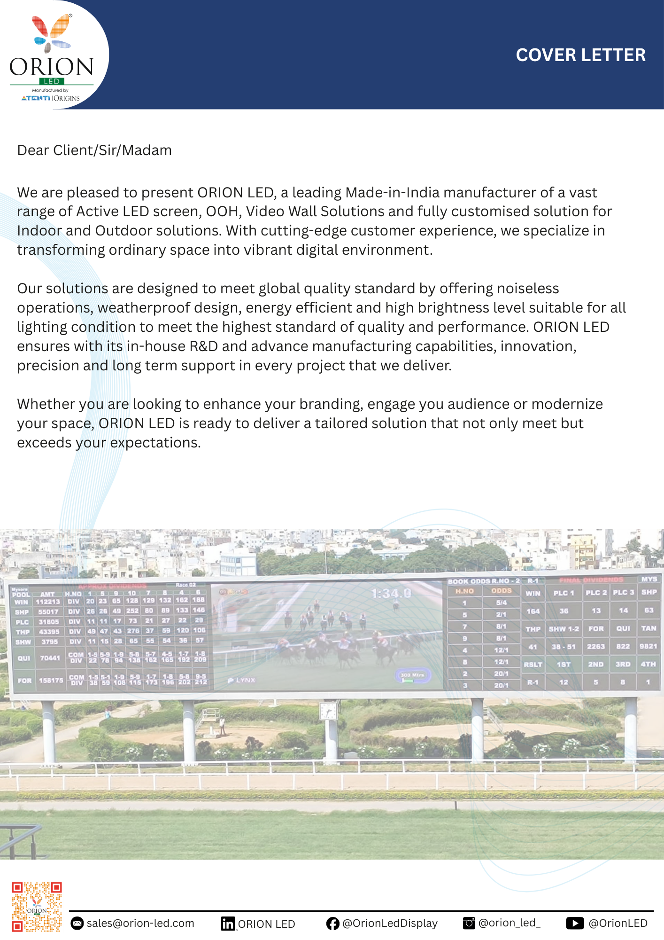

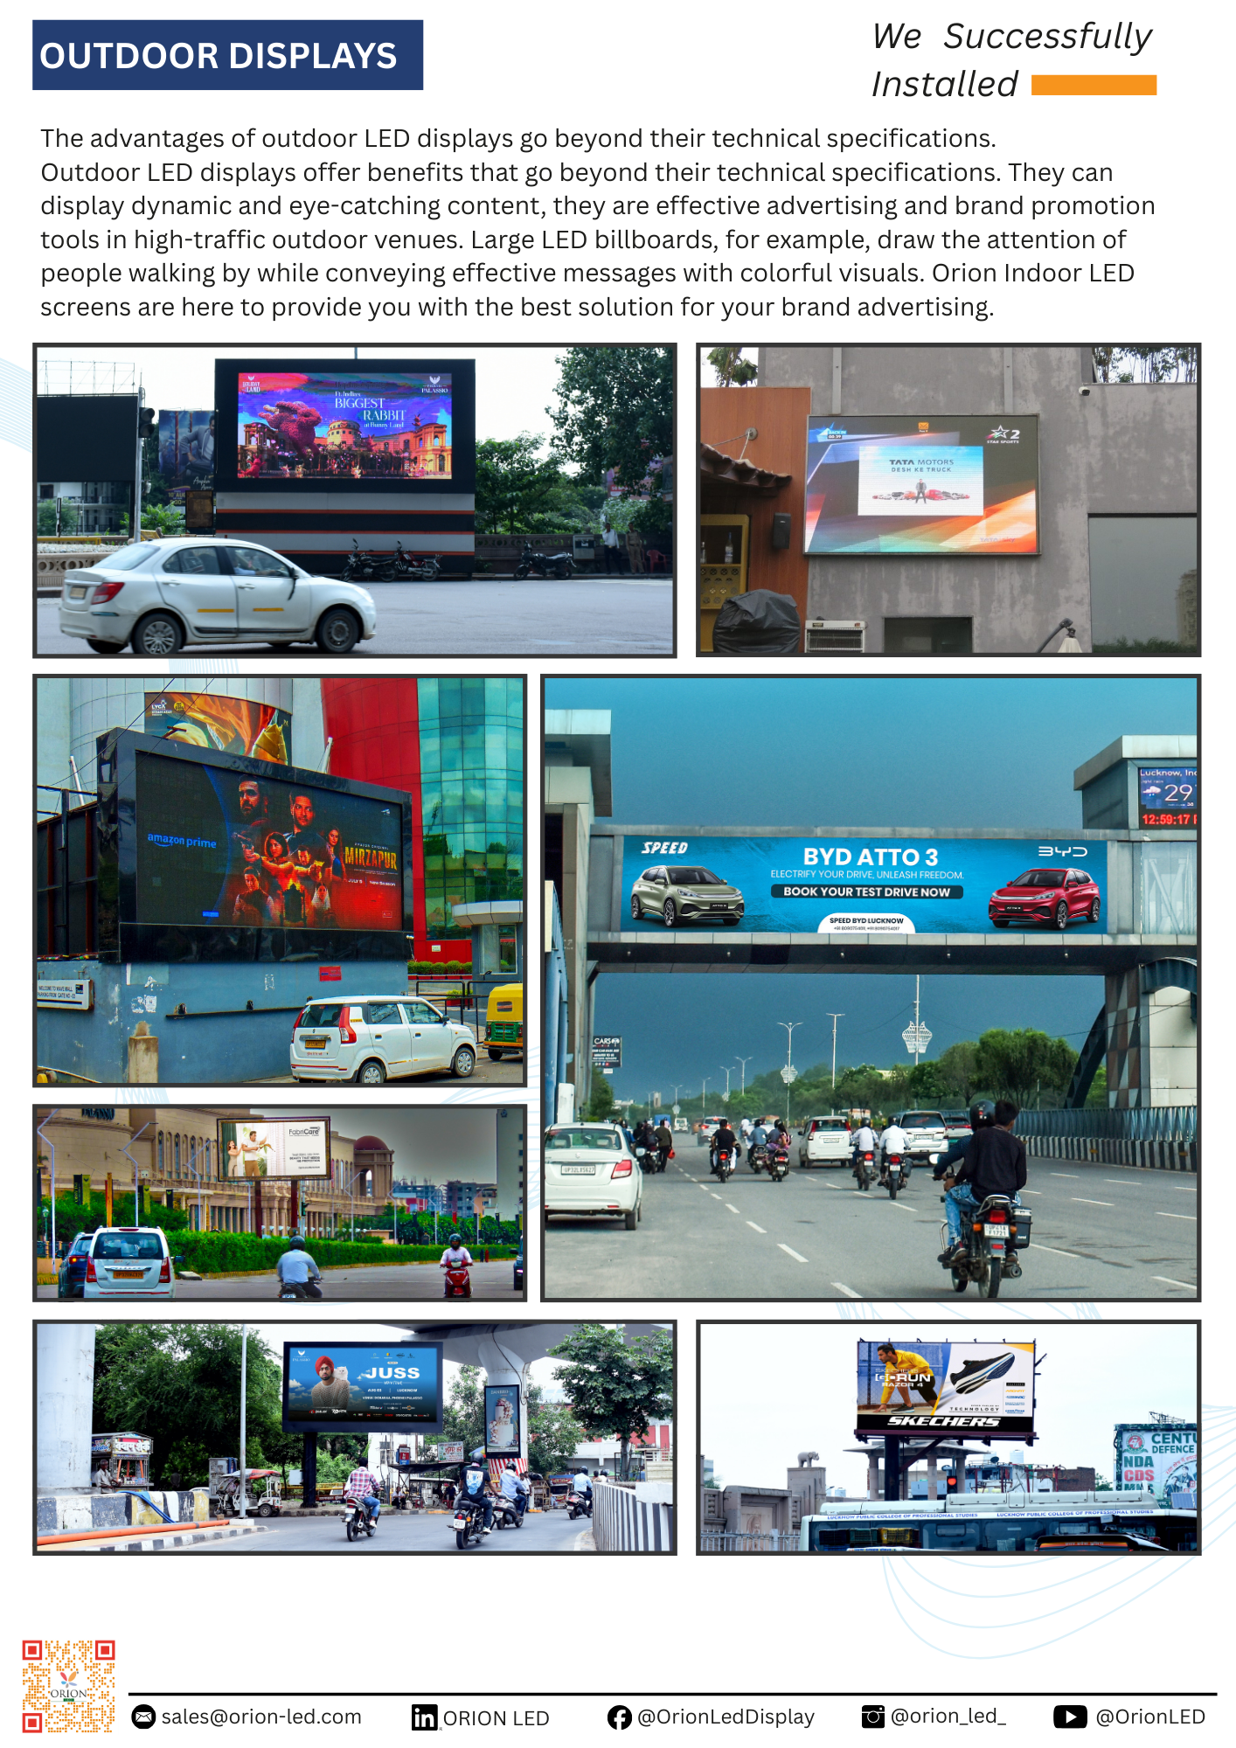

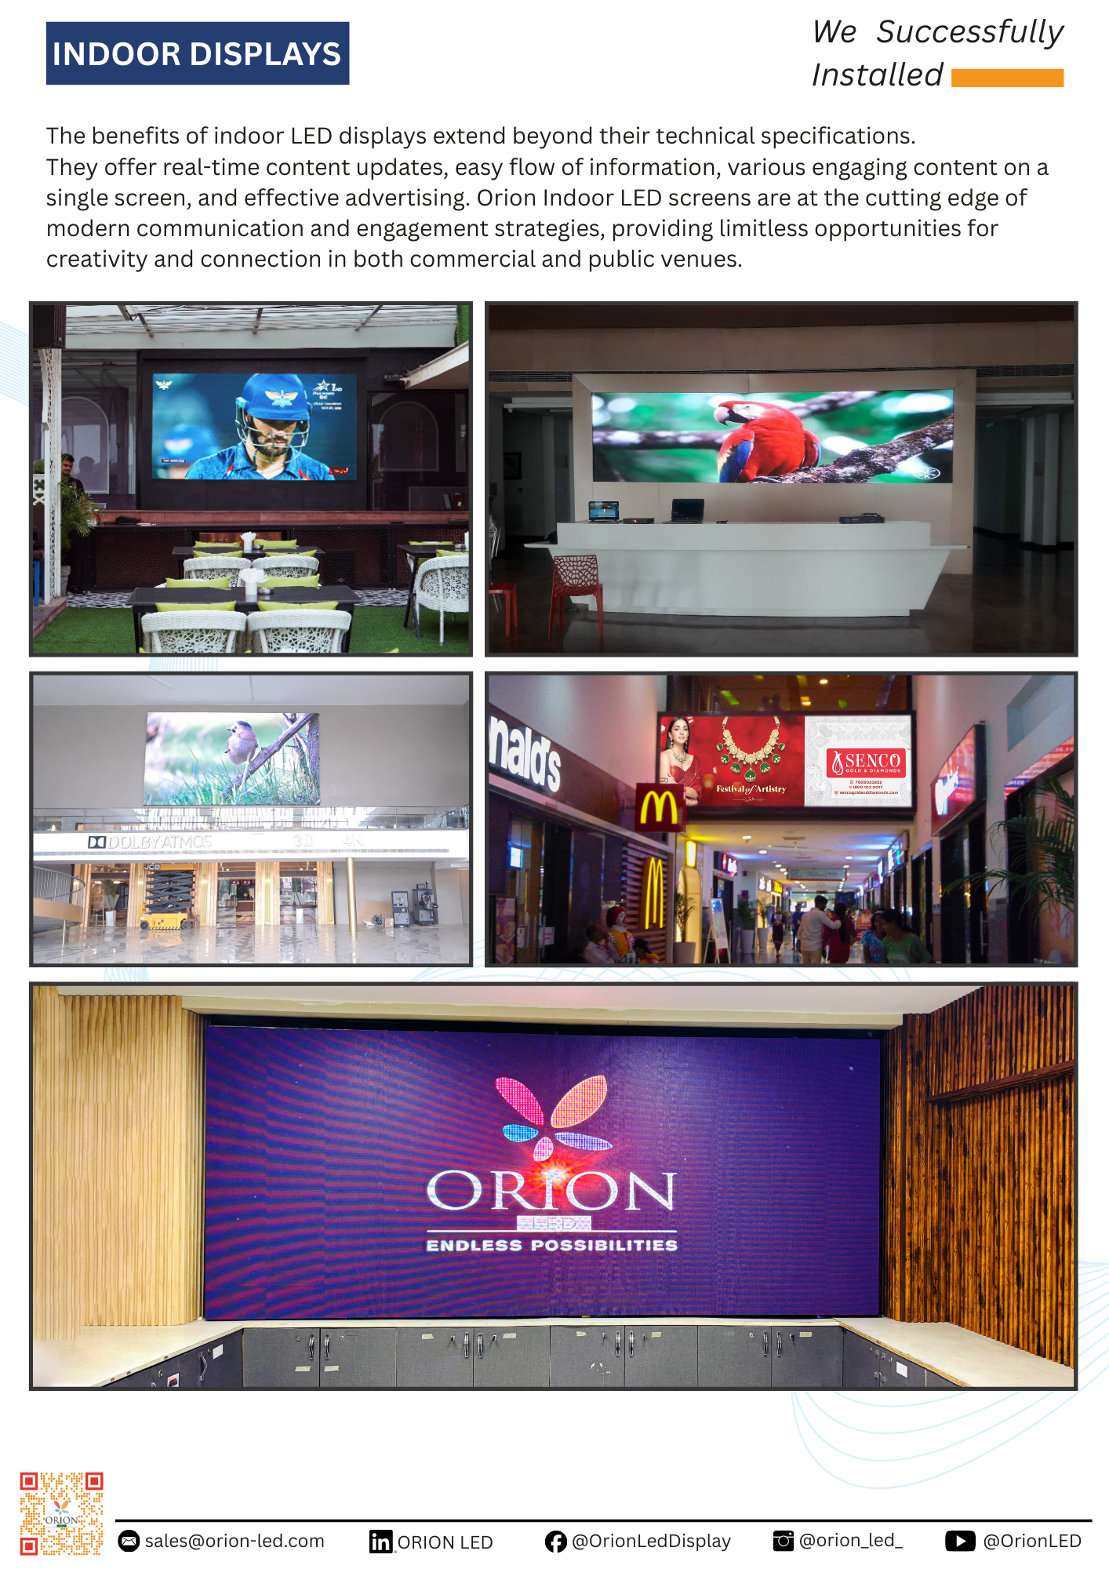

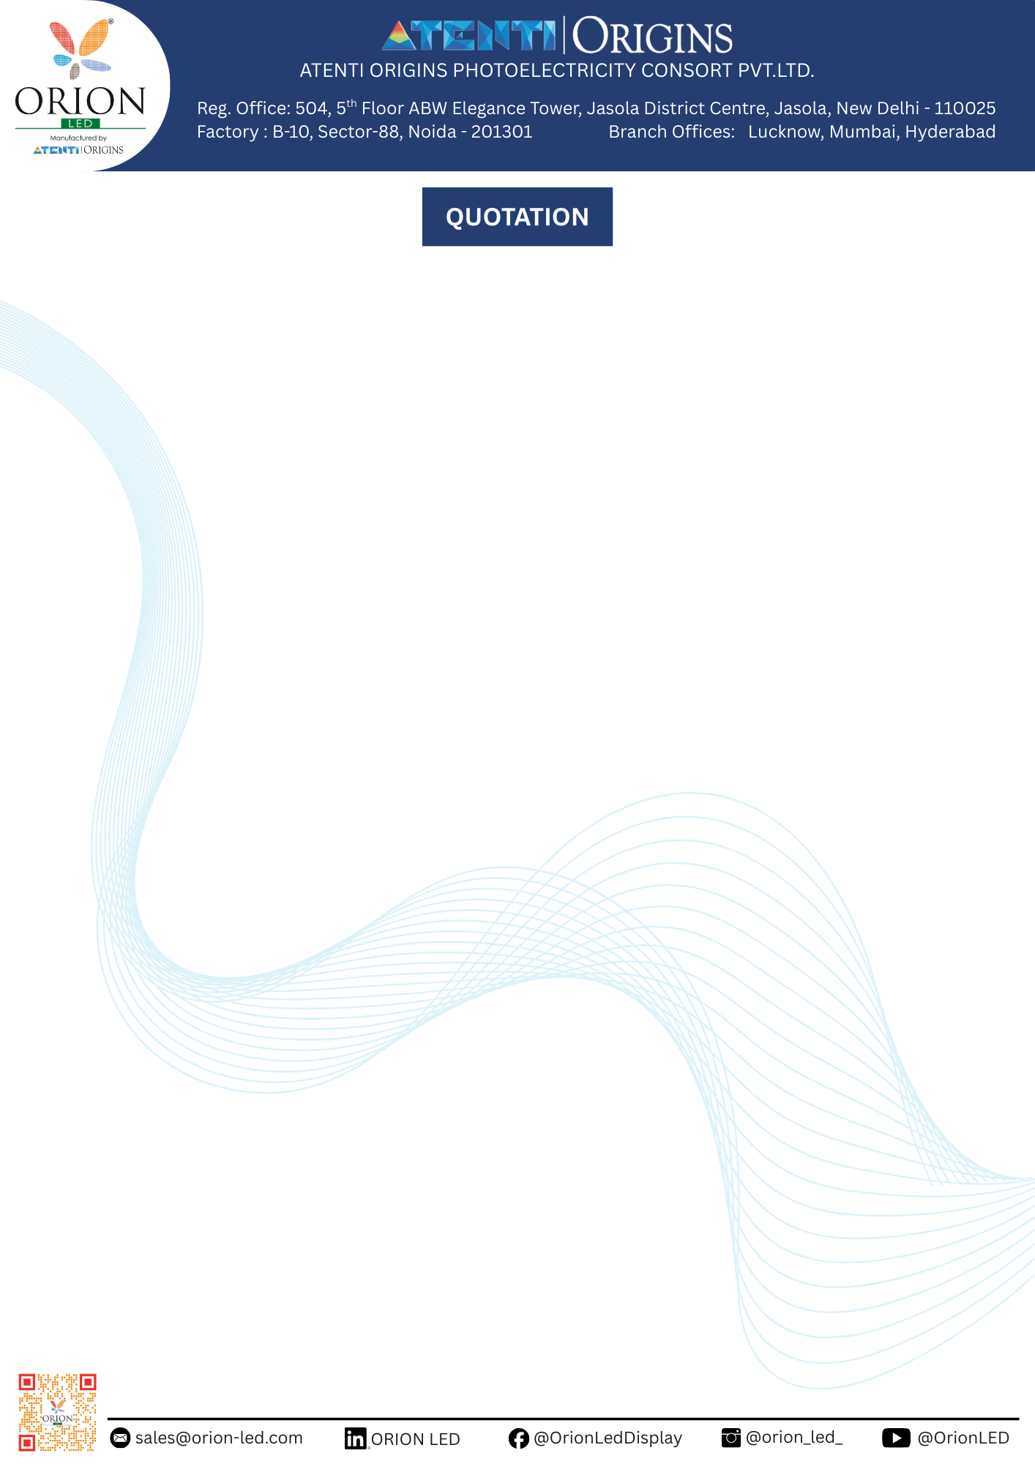

|  |  |  |  |  |  |  |  |
| --- | --- | --- | --- | --- | --- | --- | --- |
|  | ***Atenti Origins Photoelectricity Consort Pvt Ltd.  504, 5th Floor ABW Elegance Tower, Jasola District Center, Jasola, New Delhi - 110025 GSTIN-07AACCO1103D2Z7*** | | | **Quotation #** | | **ORION/2025/011/PRACHI/0301** | |
| **Date** | | **15/11/25** | |
|  | | | |
| **Client Details** | | | **ORION Details** | | | |
| Project Name | Ayodhya Development Authority (Eagle Construction | | | Location | Lucknow | | |
| Contact Person Name | Mr. Ayushman | | | Sales Person | Mr. Ashwani Yadav | | |
| Contact & E-mail | 99359 95151 | | | Contact Number | 98391 77083 | | |
| Company Address | Lucknow | | | Email ID | ashwani.yadav@orion-led.com | | |
| **Product Description** | | | **Unit Price** | **Quantity** | **UOM** | **Price** | **GST (Extra)** |
| Series/Indoor/Outdoor | **Bellatrix** | **Outdoor** | 8,100 | 19.85 | ft2 | ₹1,60,785 | 18% |
| Pixel Pitch | **P4** | |
| Cabinet Dimension in mm (W X H) | 960 | 960 |
| Display Size in mtr (W X H) | 1.92 | 0.96 |
| Display Size in ft (W X H) | 6.3 | 3.15 |
| Display Resolution in pixels (H X V) | 480 | 240 |
| Matrix | 2 | 1 |
| **TOTAL A** | | **Amount** | | |  | ₹1,60,785 |  |
| **Control System & Accessories** | |  | | | | | |
| Controller - Model | **Nova** | **TB2** |  | 1 | Nos. | ₹35,000 | 18% |
| **TOTAL B** | | **Total Amount** | | |  | ₹35,000 |  |
| **LED Structure & LED Installation** | |  | | | | | |
| LED Structure | |  | | |  | ₹50,000 | 18% |
| Transportation | |  | | |  | ₹10,000 |  |
| **TOTAL C** | | **Total Amount** | | |  | ₹60,000 |  |
| **TOTAL Price (A+B+C)** | | | | |  | **₹2,55,785** |  |

|  |  |
| --- | --- |
| **TERMS AND CONDITIONS** | |
| Validity | Offer shall remain valid for period of 30 days from the date of quotation made. |
| **GST** | **Extra as applicable at the time of invoicing. The current GST rates are indicated above** |
| Warranty | LED Display – 24 months from the date of installation or 25 months from the date of supply whichever is earlier, Controller - 12 months from the date of installation of 13 months from the date of supply whichever is earlier. |
| Payments Terms | 50% Advance at the time of placing order, 40% Before Shipment, 10% At the time of installation |
| Bank Account Details | A/C Holder Name - Atenti Origins Photoelectricity Consort Pvt Ltd. Branch Name- ICICI Bank. Sector 50, Noida |
| A/C Number - 628405020381 IFSC Code - ICIC0006284 |
| Fright & Insurance | Extra at actuals |
| Delivery Lead Time | 5-6 Weeks from Advance Payment. |
| Mode of Transportation | By Road |
| Structure | If not quoted above, then needs to be provided by the customer. If provided by customer, all the responsibilities and liabilities because of structural issues will lie with the customer. Indicated price is subject to site inspection & approval of drawings |
| Spares | 2% spares will be supplied with the main supply |
| **Once an order has been placed, it cannot be cancelled.** | |
| **Above prices are based on the configuration as provided, additional charge will be in client's account if any parts changed.** | |
| **Electrical wiring & Accessories (MCB, TPN, RCCB), UPS, CAT6 wire, Network cabling, Fabrication, Civil, Electrical, Conduiting at Client end.** | |
| **Conduiting / Trunking / LAN /Power points /scaffolding/Ladder/SRP etc are Client's scope or by client's Electrical Contractor.** | |
| **Earthing wire should be of same specification with live & neutral (Client End)** | |

